Development Sheet

**Taniwha Tide Game**

**Purpose: T**o strengthen student understanding of key mathematical concepts (algebra & fractions) through engaging 2D side-scrolling game inspired by Māori mythology encouraging confident learning in a culturally rich setting.

|  |  |
| --- | --- |
| **Target Audience** | |
| **Primary** | **Year 7 students needing maths support or enrichment** |
| **Secondary** | **Teachers seeking interactive math-based classroom tools** |
| **Tertiary** | **Parents encouraging meaningful learning through play** |

**Gameplay Overview**

A side scrolling underwater quest where players control a guardian taniwha swimming through zones filled with math puzzles, obstacles like nets and jellyfish, and sacred rings that reveal questions. Correct answers unlock movement or bonuses; incorrect ones trigger traps or slowdowns

**Research**

|  |  |
| --- | --- |
| **Area** | **Details** |
| **Focus area** | Boosting engagement through culturally integrated math games |
| **Method** | NZ Curriculum alignment, peer testing, educator feedback |
| **Output** | A 2D playable game with algebra and geometry questions |
| **Game Impact** | Improved motivation, mathematical retention, and cultural appreciation |

**Core math topics covered**

|  |  |  |
| --- | --- | --- |
| Lvl | Math Topic | Description |
| 1 | Fractions | Simplifying and solving |
| 2 | Algebra | Solve basic equations (one- and two-step solving) |

**Game Design**

|  |  |
| --- | --- |
| **Element** | **Details** |
| **Gameplay** | Educational side-scrolling quest |
| **Genre** | Math adventure with cultural depth |
| **Theme** | Mystical underwater legends + logical challenge |
| **Story** | A taniwha must restore order by solving maths challenged set by ancient guardians |
| **Platform** | Desktop (windows/macOS) - school friendly |
| **Tech stack** | Python + pygame |
| **Rules** | Correct answers move player forward; incorrect ones trigger visual clues or obstacles |

**Layout analysis**

**Side-scrolling layout**

|  |  |
| --- | --- |
| **Pros** | **Cons** |
| Easy navigation: left, right, up (jump) | Less exploration dept compared to top-down |
| Clear progression per lvl | Requires tight sprite placement and collisions |
| Great for simple math trigger positioning | Linear storyline may limit branching quests |
| Familiar to platform gamers (easy to play) |  |

**Visual Design**

|  |  |
| --- | --- |
| **Element** | **Details** |
| **Art style** | Pixel based ocean graphics, soft animation |
| **Tools used** | Piskel (sprites), Canva (backgrounds), Trello (project planning) |
| **Characters** | Taniwha (player) |
| **Visual feedback** | Blue glow = correct; red pulse/shake = incorrect; splash animations for obstacles |

**Scope definition**

|  |  |  |
| --- | --- | --- |
| Category | Included features | Might include (future) |
| Includes | 2 lvls, math rings, obstacles, practice mode |  |
| Might include | Boss spirit battle, mini voiceovers, branching paths |  |

**Requirements of my outcome**

* Clear instructions at start and per lvl
* Scalable maths (easy to slightly complex)
* Mythically inspired hero character
* Visual clarity, bold text, ad supportive interface
* Quick retry/replay system

**Relevant implications**

|  |  |
| --- | --- |
| **Area** | **Impact** |
| **Educational** | Builds foundational algebra and geometry skills through play |
| **Cultural** | Respectfully integrates Māori mythology |
| **Technical** | Lightweight and compatible across school computers |

**Mind Map: Lucid Chart**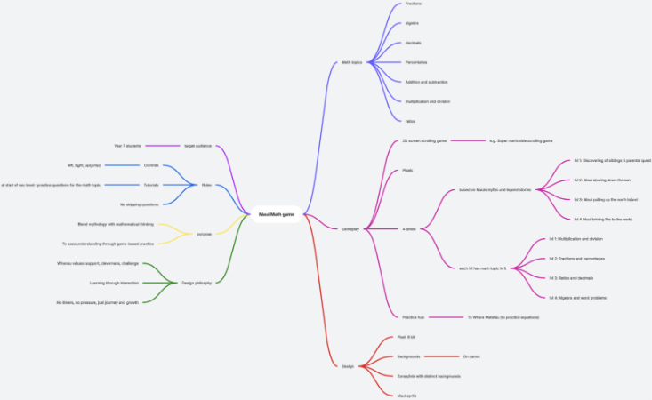

**Mind map Summary**

|  |  |
| --- | --- |
| **Category** | **Notes** |
| **Subject** | Year 7 Mathematics |
| **Target audiences** | Students, teachers, parents |
| **purpose** | Boost math confidence through immersive cultural gameplay |
| **gameplay** | Side-scrolling Ocean puzzle quest |
| **Story** | Taniwha restores balance by unlocking maths wisdom |
| **design** | Pixel art, reef zones, spiritual rings |
| **genre** | Educational math adventure |
| **Platform** | Desktop (Python + Pygame) |
| **rules** | Solve math challenged to swim forward |
| **Visual design** | Ocean backgrounds, ring trigger, power ups |
| **Tools** | Piskel, Canva, Trello (Kanban) |
| **Characters** | Taniwha |

Plan Development

|  |  |  |  |
| --- | --- | --- | --- |
| What | How | Notes | Tools |
| Project management | Explored Trello, Scrum, and Kanban | Trello chosen for versio-based solo workflow | Trello (Kanban), Microsoft Word |
| Trial of tools | Tested all three methods | Kanban suited flexible version builds | Trell board |
| Sprite planning | Each coding version acts as a sprint (v1 – v11) | Milestones mapped to version control log | Trello versions + labels |
| Record of changes | Logged layout adjustments and feature development | All changed tracked via Trello comments | Trello comments |
| Agile Vs Waterfall | Agile model selected for adaptive coding structure | Feedback-driven, version-based development | Trello + weekly Gnatt Chart |

Manage Development

|  |  |  |  |
| --- | --- | --- | --- |
| What | How | Notes | Tool used |
| PM Workflow | Trello Kanban board: Backlog -> To Do -> In Progress -> Code review -> testing -> Done | Allows clear visualization of task phases | Trello Kanban |
| Tool Trial | Compared scrum and Kanban workflows | Kanban supports solo dev and evolving codebase | Trello cards |
| Dev Logging | Tracked code updates with screenshots and notes | Evidence attached to versioned Trello cards | Trello + Coding sheet |
| Kanban Usage | Continuous card movement reflects modular sprint cycle | Adapts well to version-based delivery | Trello Board |
| Full tracking | Entire game development monitored through Trello | Each card tagged with version number and status | Trello End-to-End |

Version Control Log: Taniwha Tide: Depths of Knowledge

|  |  |  |  |
| --- | --- | --- | --- |
| Platform | Date | What I did | Evidence |
| GitHub + VS Code | 17/07/25 | V1 – initialized game window, created title screen, inserted placeholder taniwha sprite (start button) |  |
| GitHub + VS Code | 21/07/25 | V2 – Added swim movement logic and basic zone layout; initial math ring triggers tested |  |
| GitHub + VS Code | 22/07/25 | V3 – Created obstacle logic for nets and jellyfish; added red pulse feedback for incorrect answers |  |
| GitHub + VS Code | 23/07/25 | V4 – Developed sacred ring math questions system; glow logic implements for correct/incorrect answers |  |
| GitHub + VS Code | 24/07/25 | V5 – Created Fractions Zone (Level 1) and Algebra Zone (Level 2). Developed fraction equations (simplifying and solving) and algebra equations (one- and two-step solving). |  |
| GitHub + VS Code | 25/07/25 | V6 – Updated sprite system with idle/swim frames; refined collision and visual polish |  |
| GitHub + VS Code | 26/07/25 | V7 – Added Lvl transition animation and refined ring placement for smoother progression |  |
| GitHub + VS Code | 26/07/25 | V8 - Developed power-up and replay function with performance summary |  |
| GitHub + VS Code |  | V9 – Created win screen and replay function with performance |  |
| GitHub + VS Code |  | V10 – Final polish background layering, text styling alignment fixes |  |
| GitHub + VS Code |  | V11 - |  |

Gnatt Chart Plan

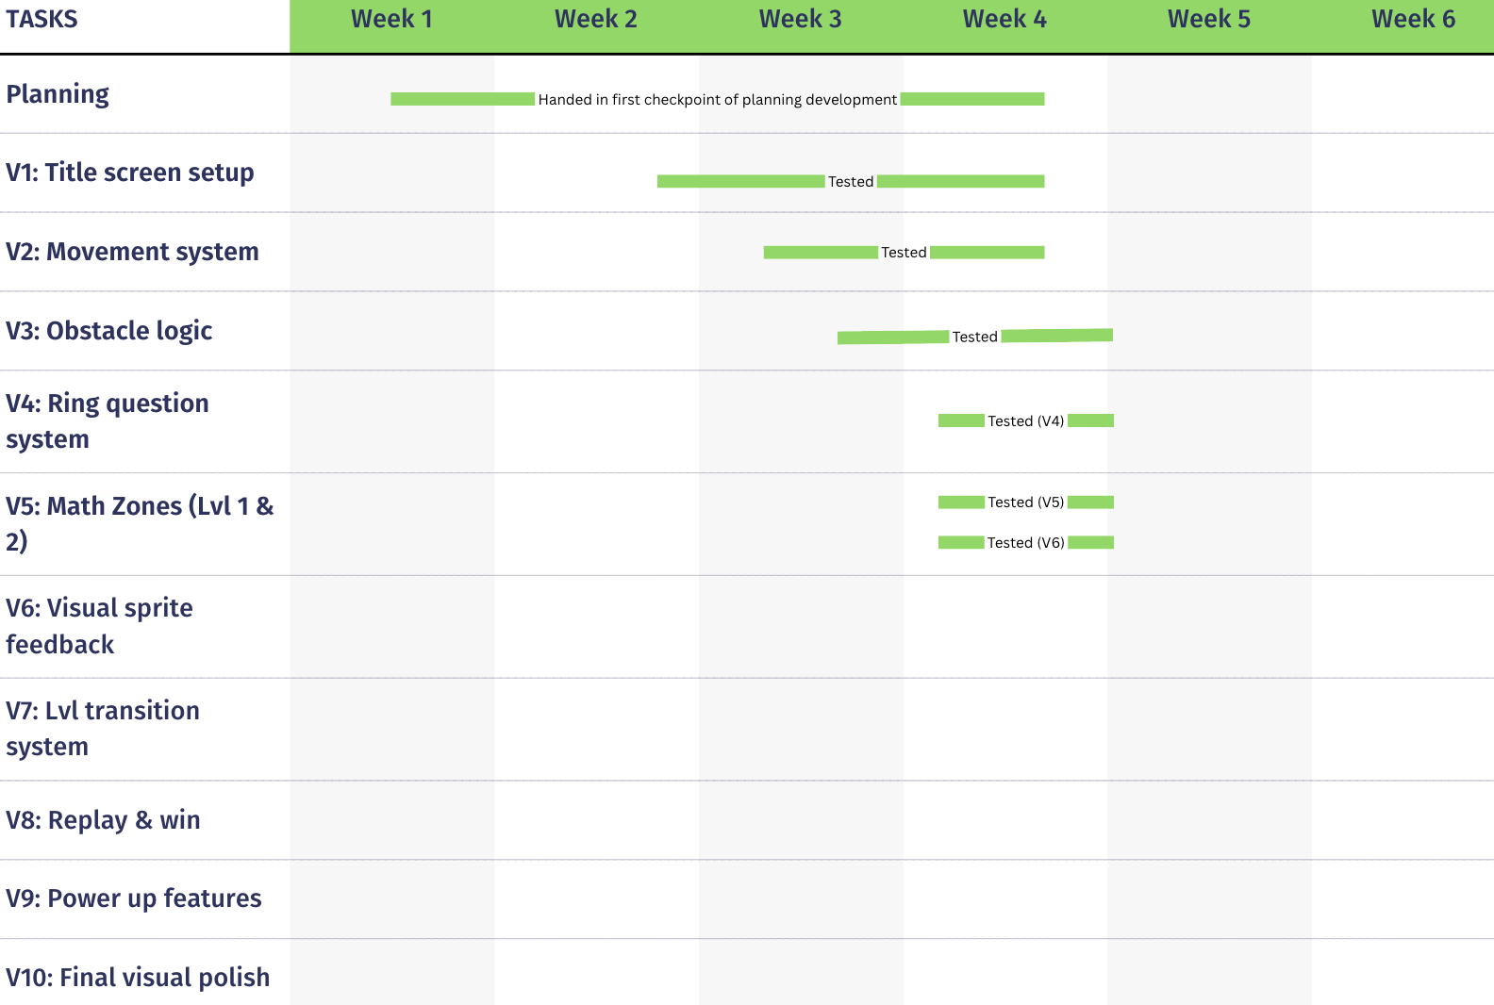

**Testing sheet**

**< Taniwha’s Tide >**

|  |  |  |  |  |
| --- | --- | --- | --- | --- |
| **Expected cases** | | | | |
| **Testing for:** | | | | |
| **Input** | **Expected Output** | **Actual Output** | **Correct?** | **Debugging notes** |
|  |  |  |  |  |
|  |  |  |  |  |
| **Testing for:** | | | | |
|  |  |  |  |  |
|  |  |  |  |  |
| Testing for: | | | | |
|  |  |  |  |  |
| **Testing for:** | | | | |
|  |  |  |  |  |
| **Testing for:** | | | | |
|  |  |  |  |  |
| **Testing for:** | | | | |
|  |  |  |  |  |
| **Testing for:** | | | | |
|  |  |  |  |  |
| **Testing for:** | | | | |
|  |  |  |  |  |
| **Testing for:** | | | | |
|  |  |  |  |  |
| **Testing for:** | | | | |
|  |  |  |  |  |
| **Testing for:** | | | | |
|  |  |  |  |  |
| **Testing for:** | | | | |
|  |  |  |  |  |
| **Testing for:** | | | | |
|  |  |  |  |  |
| **Testing for:** | | | | |
|  |  |  |  |  |
| **Testing for:** | | | | |
|  |  |  |  |  |
|  |  |  |  |  |
| **Boundary Cases** | | | | |
| **Testing for:** | | | | |
| **Input** | **Expected Output** | **Actual Output** | **Correct?** | **Debugging notes** |
|  |  |  |  |  |
| **Testing for:** | | | | |
|  |  |  |  |  |
| **Testing for:** | | | | |
|  |  |  |  |  |
| **Testing for:** | | | | |
|  |  |  |  |  |
| **Testing for:** | | | | |
|  |  |  |  |  |
| **Testing for:** | | | | |
|  |  |  |  |  |
| **Testing for:** | | | | |
|  |  |  |  |  |
| **Invalid Cases** | | | | |
| **Testing for:** | | | | |
| **Input** | **Expected Output** | **Actual Output** | **Correct?** | **Debugging notes** |
|  |  |  |  |  |
| **Testing for:** | | | | |
|  |  |  |  |  |
| **Testing for:** | | | | |
|  |  |  |  |  |

**Trailing**

**Component details**

|  |  |
| --- | --- |
| Components |  |
| What testing and trailing did I do? |  |
| What I found out |  |
| What I did because of this |  |
| Evidence |  |

**Technique Comparison**

|  |  |
| --- | --- |
| What alternative techniques or components did I trial? |  |
| Which did I choose and why? |  |
| Before and after screenshot |  |

**Design Implications**

|  |  |
| --- | --- |
| What implications are relevant to this component and why? |  |
| How did I address these implications |  |

**Project Managment**

|  |  |
| --- | --- |
| Project management and version control tool at this point in the project |  |
| Evidence |  |

**Stakeholder feedback**

|  |  |  |
| --- | --- | --- |
| Name | Feedback | Improvements |
|  |  |  |
|  |  |  |
|  |  |  |

**Documentation for what I have done**

|  |  |  |  |  |
| --- | --- | --- | --- | --- |
| Date | What I’m doing | Why I did it (more for coding) | Evidence (for codes – the added code for versions and the code working) | Improvement |
| 17/06/25 | Started planning game concept – created mind map for Taniwha Tide | To explore how Māori mythology could shape a math adventure game for year 7 students | (mindmap) |  |
| 26/06/25 | Drafted development sheet – write purpose, target audiences, math topics, and gameplay | To define the educational goals and structure early game zones and features | (picture of it) | Refined algebra and fraction topics to reflect real year 7 curriculum struggles |
| 27/06/25 | Assigned math topics to planned Lvls | To align math progression with both Lvls | Screenshot of it | Confirmed structure for 2 Lvls (algebra, fractions) removed excessive Lvl |
| 28/06/25 | Decided the layout for my game – i choose to do a 2D Side scrolling game | To find the easiest movement system for cofing and best experience for students | Screenshot of the pros and cons | Final decision: side- scrolling layout for simpler movement and zone progression |
| 15/07/25 | Submitted development sheet for checkpoint | Finalized documentation and project structure | (screenshot of it in teams and feedback given) | Added time management breakdown with version goals and Gnatt Chart |
| 16/07/25 | Choose Trello Kanban system to manage my coding sprints. Also created my Gnatt Chart | To track tasks and build version goals across each Lvl | (screenshot of created Trello board) | Linked cards with version labels and milestone checklist |
| 17/07/25 | Started Version 1 – coded title screen, set game window size, added red block as taniwha placeholder | To set up visual base of the game and establish cultural presence with myth inspired title | (screenshot of code, and of the working code) | Replace block sprite with Taniwha art from Piskel, stylized title text for theme consistency |
|  | Trello and Gnatt Chart update |  | (Trello board and gnat chart) |  |
| 21/07/25 | Started Version 2 – added side-swim movement system and key controls | To make movement smooth and intuitive for players, prepare for trigger zones | (screenshot of code, and of the working code) | Adjusted speed, refined edge collision logic to keep within bounds |
|  | Trello and Gnatt Chart update |  | (Trello board and gnat chart) |  |
| 22/07/25 | Started Version 3 – added nets and jellyfish obstacle logic, programmed collision detection | To build challenge mechanics that encourage problem-solving and visual feedback | (screenshot of code, and of the working code) | Tweaked obstacle placement and trap sizes for fair challenge Lvls |
|  | Trello and Gnatt Chart update |  | (Trello board and gnat chart) |  |
| 23/07/25 | Started Version 4 – built sacred ring trigger system, created math pop up logic | To implement learning system that rewards correct answers and tracks progress | (screenshot of code, and of the working code) | Added glow feedback for correct answers and red pulse for wrong input |
|  | Trello and Gnatt Chart Update |  | (Trello board and gnat chart) |  |
| 23/07/25 | Started Version 5 – Created Fractions Zone (Lvl 1) and Algebra Zone (Lvl 2). Developed fraction equations (simplifying and solving) and algebra equations (one- and two-step solving). | To introduce 2 key math Lvls aligned to Year 7 learning goals, focused on equation-solving for numeric fluency and logic | (screenshot of code, and of the working code) | Refined question formatting and progression pacing to support equation – based learning |
|  | Trello and Gnatt Chart Update |  | (Trello board and gnat chart) |  |
| 25/07/25 | Started Version 6 – loaded sprite animation transitional visuals | To make gameplay smoother and visually clearer across Lvls | (screenshot of code, and of the working code) | Fixed animation loop issues, layered backgrounds with ocean textures |
|  | Trello and Gnatt Chart Update |  | (Trello board and gnat chart) |  |
| 26/07/25 | Started Version 7 - |  | (screenshot of code, and of the working code) |  |
|  | Trello and Gnatt Chart Update |  | (Trello board and gnat chart) |  |
| 27/07/25 | Started Version 8 - |  |  |  |
|  | Trello and Gnatt Chart update |  |  |  |
| 27/07/25 | Started Version 9 - |  |  |  |
|  | Trello and Gnatt Chart update |  |  |  |
|  | Started Version 10 - |  |  |  |
|  | Trello and Gnatt Chart update |  |  |  |
|  | Started Version 11 - |  |  |  |
|  |  |  |  |  |
|  |  |  |  |  |
|  |  |  |  |  |